**Fixed error:**

1. Sample id and case id doesn’t match

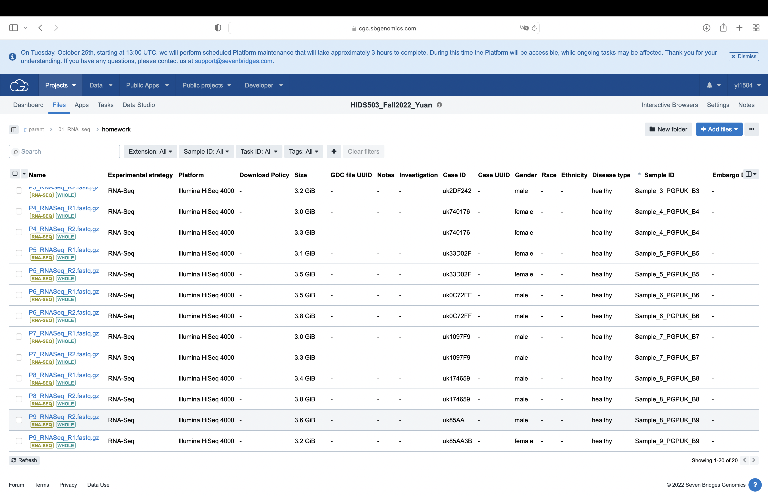      correct error

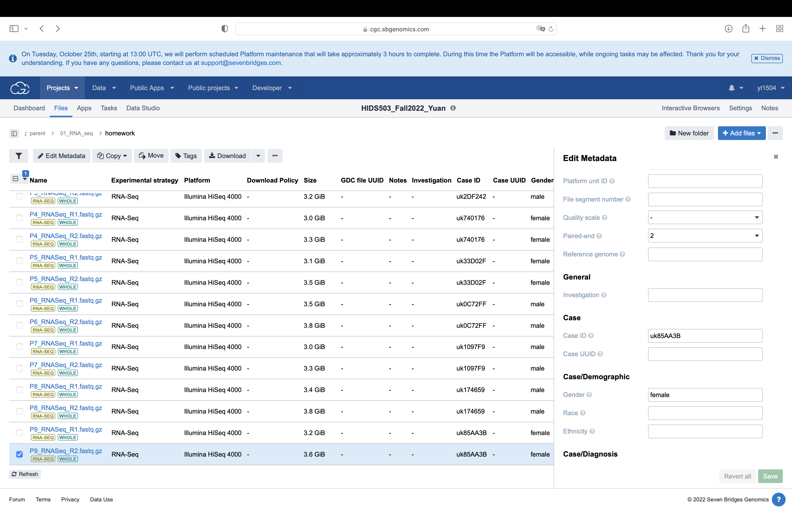

1. paired-end should be 2

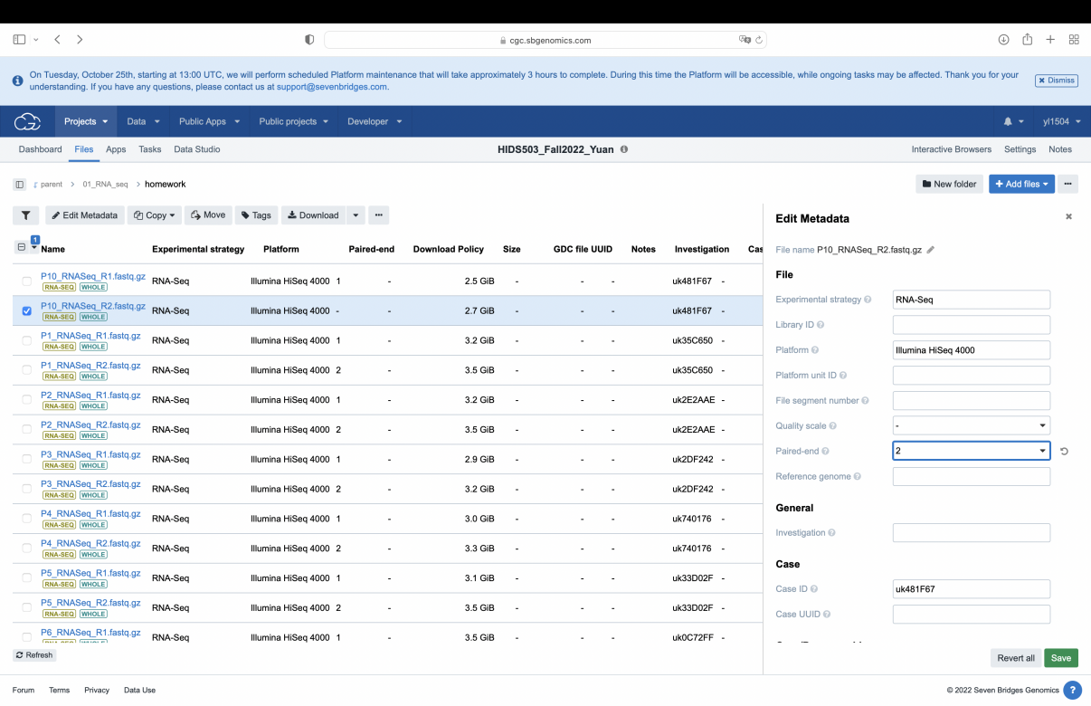**Procedure:**

Run workflow

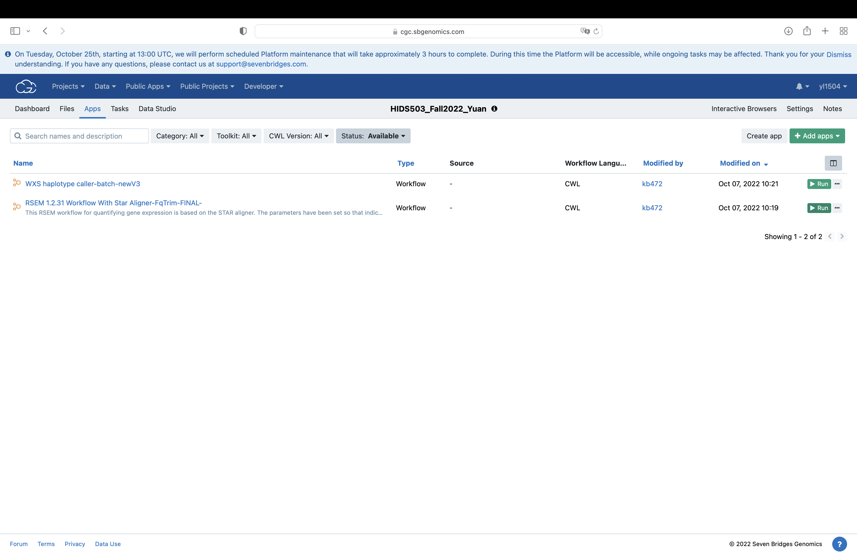

batch by sample ID

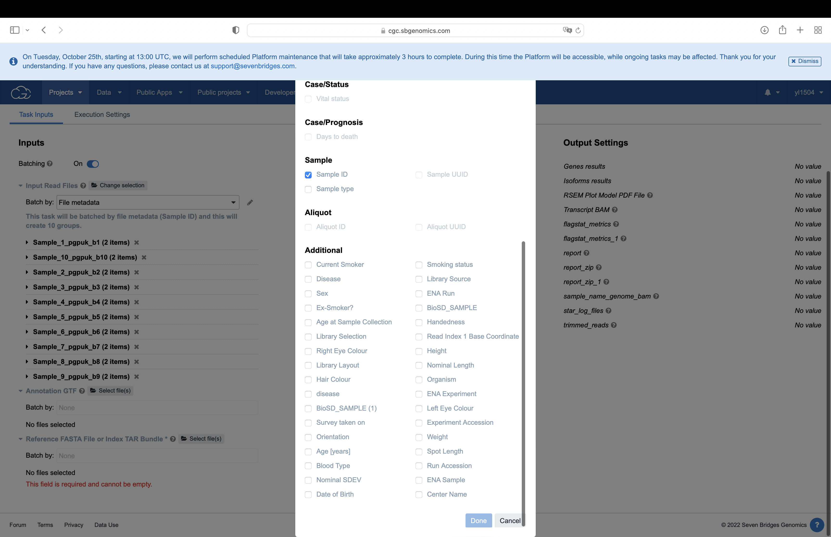

select annotation GTF and reference FASTA file

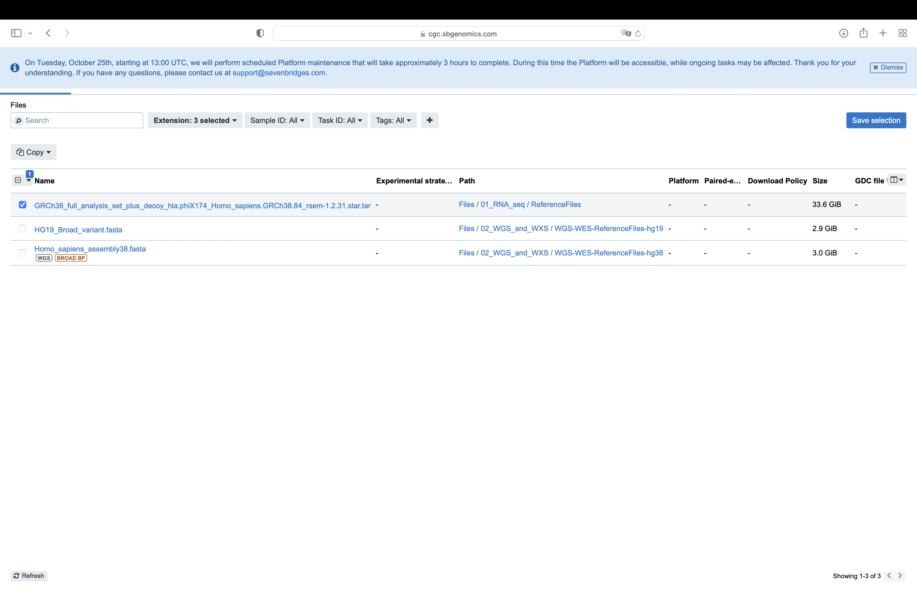

run ten task

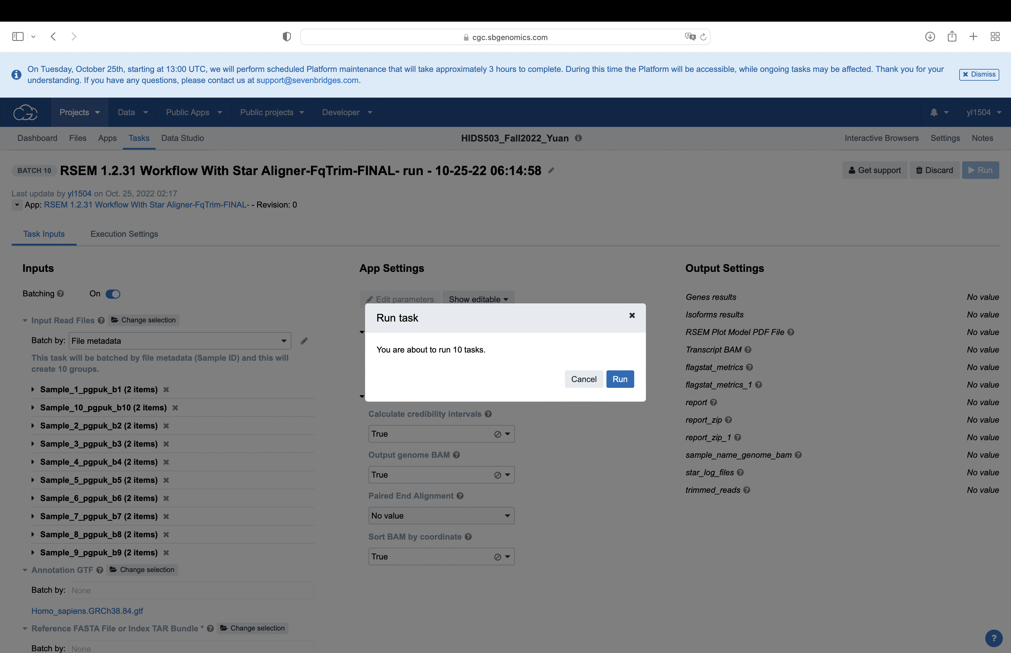

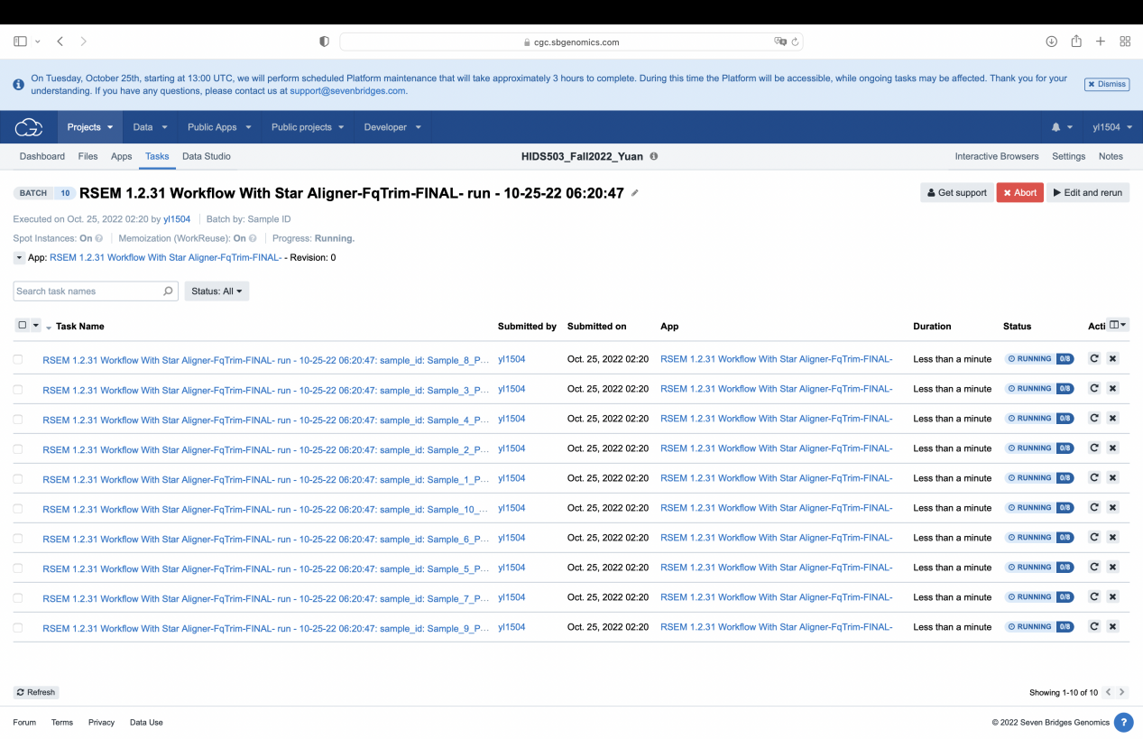

**Output**

total number of output:160

output per patient:16

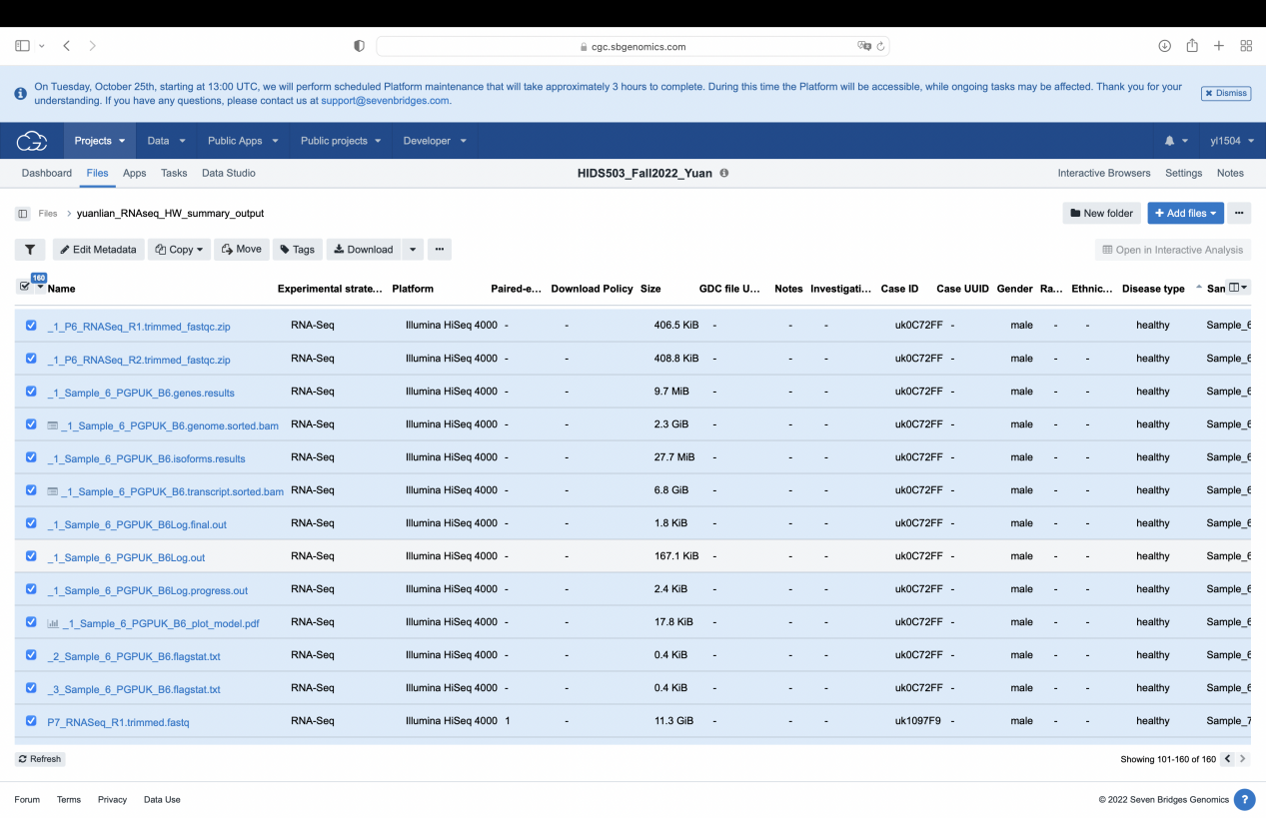

1. bam files, one on genome level and one on transcript level, contains sequence from samples as well as its location and emphasis.
2. gene expression and isoforms level files: contains gene-id, transcript-id, and several raw counts, use for group comparison
3. quality check files: quality check of input files and before/after trimming
4. log files
5. trimmed FASTQ files: fit to alignment set
6. plot files:Fragment Length Distribution
7. report file
8. metrics file